Project Description 1.0

Project Summary:

Web Pages:
 | Title | Page
 | Home | 1
 | Physical
 | Occupational
 | Hand
 | Pediatrics
 | Careers
 | Internships
 | About Us (gone) | 4
 | Locations | 6
 | Boca Grande Island | 7
 | North Port/Murdock | 8
 | Port Charlotte | 9
 | Punta Gorda | 10
 | Sarasota | 11
 | Sarasota (Downtown) | 12
 | Venice Island | 13
 | Staff Biographies | 14
 | Francisco Ramirez – north port | 15
 | Karim Wassef – gone – Micah Marazon – port char | 16
 | Nicole Urbanowski | 17
 | Nick Hughes- downtown s | 18
 | Mandy McHargue – gone baby | 19
 | Mary Beth Rudolph boca grande | 20
 | Michael Morrison - sarasota | 21
 | Michelle Harmon - venice | 22
 | Rob Lovell – punta gorda | 23
 | Shelia Flaherty – hand therapist poort charolette | 24

Functionality:
- Screen reader compatibility
- Improve Google search return position
- Google map API

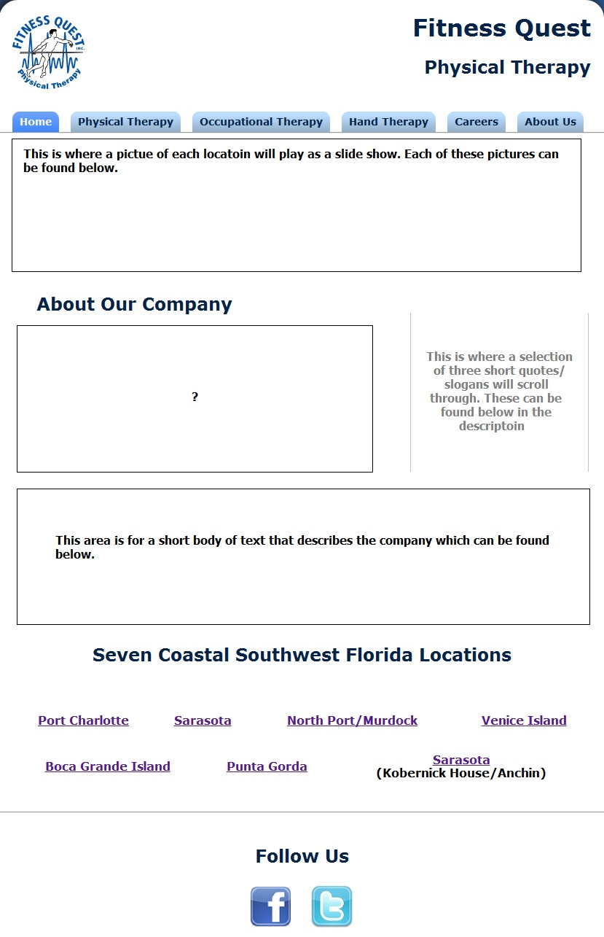
Home Layout

Home

Slogans:

?:

Short Body Text:

Physical Therapy
Occupational Therapy
Hand Therapy
Pediatrics
Careers
About Us Layout
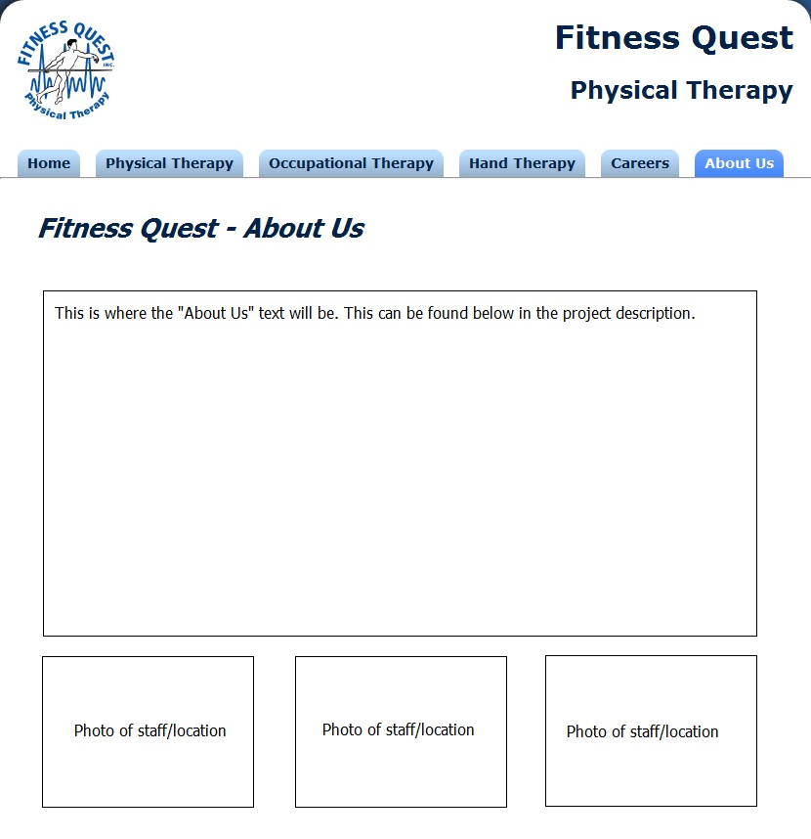
“About Us” Text:
Fitness Quest Physical Therapy offers a unique and individualized experience. We have assembled a team of professionals unparalleled in our industry, who pride themselves on setting the standard for quality patient care. Our therapists bring over 50 years of combined experience to help treat our patients. Fitness Quest Therapy is coming is committed to seeing their patients through to a life of quality restored. Our staff of highly trained professionals uses a combination of therapeutic exercises and modalities. We currently have 8 convenient locations spread throughout Sarasota and Charlotte counties in beautiful state of the art facilities. We provide Physical, Occupational, Pediatric, Massage and Hand Therapies.

We treat: (fade transition) Arthritis, Post-Surgical Rehab, Back Pain, Balance Problems, Auto Injury, Sports Injuries, Fractures, Tennis/Golfer's Elbow, Fibromyalgia, Carpal Tunnel, Joint Replacement, ACL's and Fractures. Fitness Quest, Quality plus Convenience, Let us help you regain your life!

Photo 1:

Photo 2:

Photo 3:
Locations Page Layout
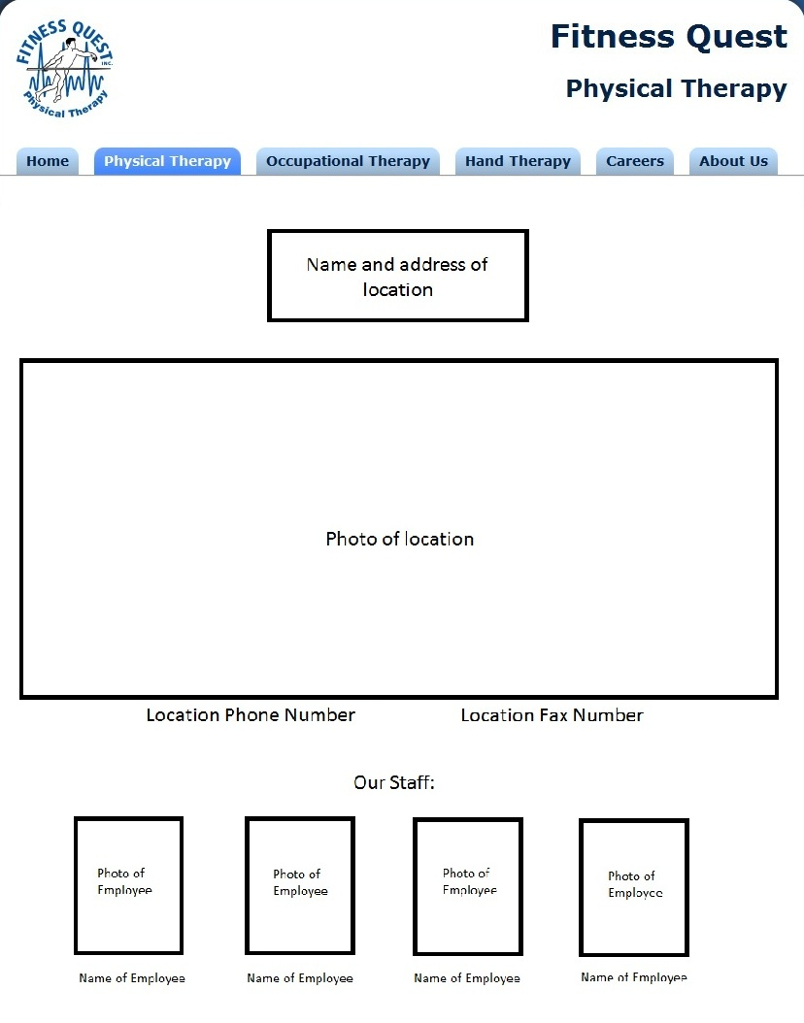
Location: Boca Grande Island
Address:
280 Park Ave.
Boca Grande, FL 33921
Photo:
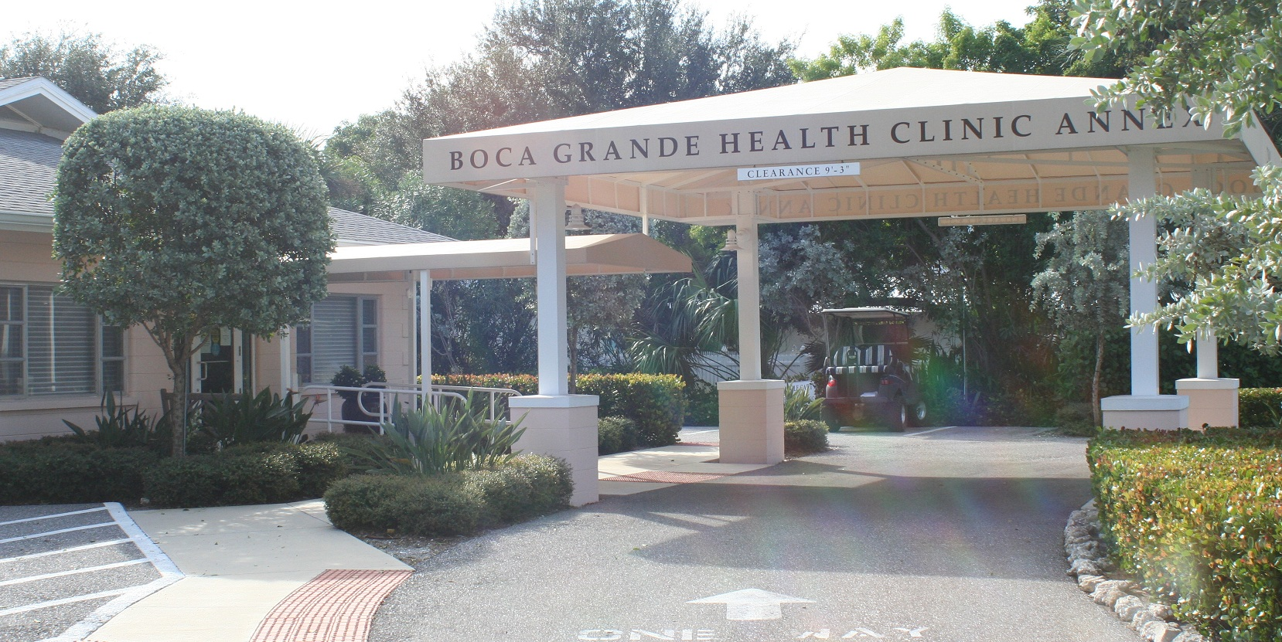
Phone Number: (941) 964-2300
Fax Number: (941) 964-2320
Staff Members: Mary Beth
Description:

Location: North Port/Murdock
Address:
2530 Bobcat Village Ctr. Rd. #C
Nort Port, FL 34288
Photo:
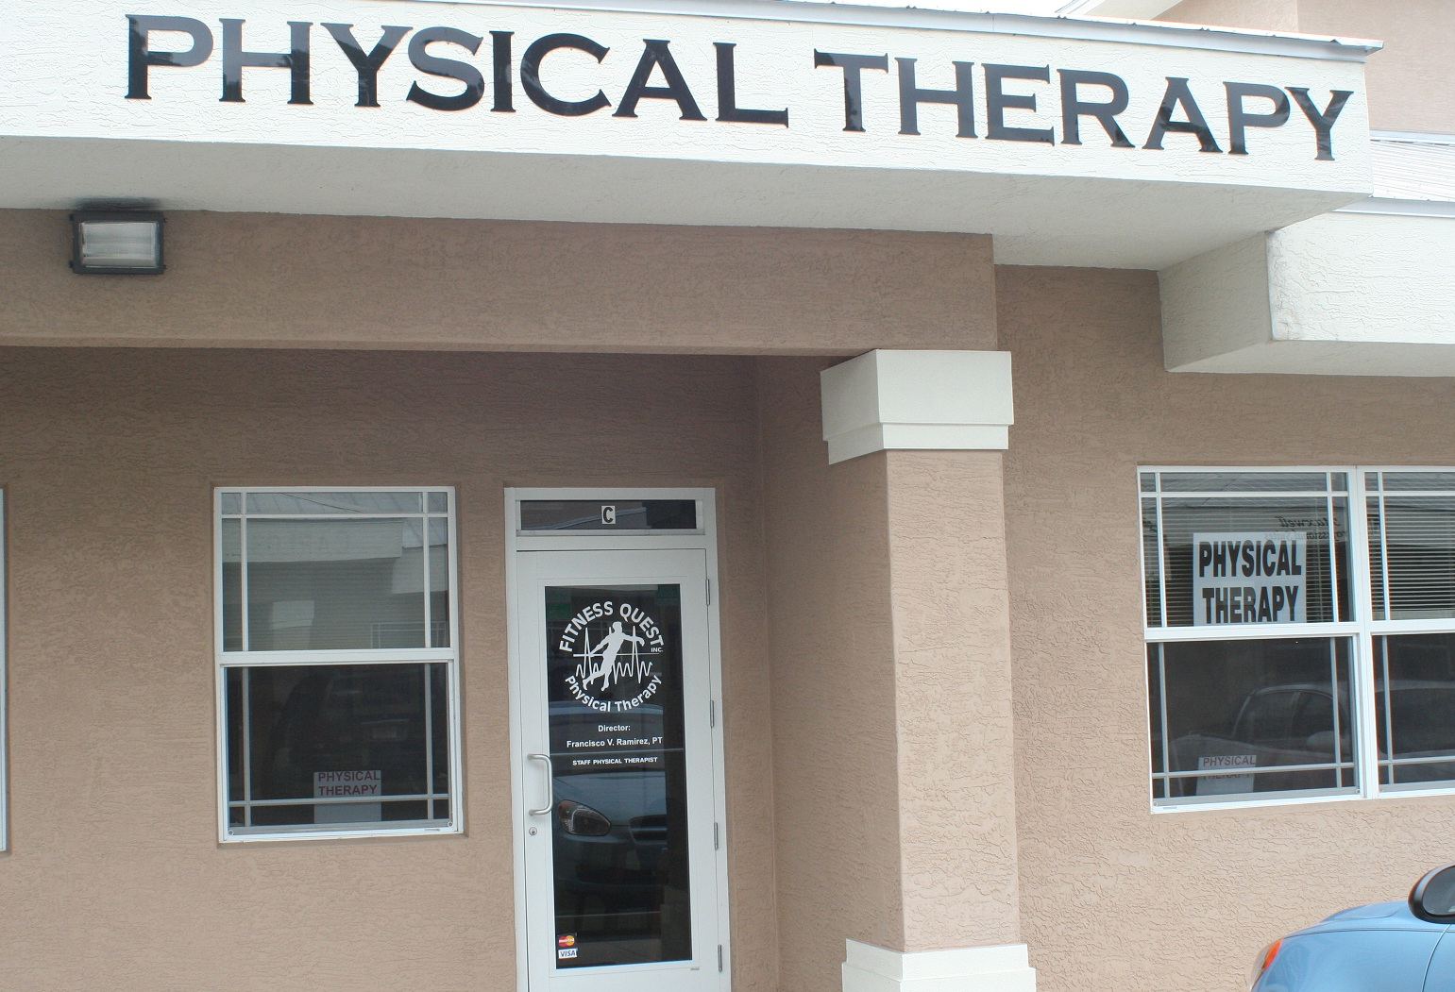
Phone Number: (941) 426-7400
Fax Number: (941) 426-7044
Staff Members: Francisco Ramirez
Description:
Location: Port Charlotte
Address:
4161 Tamiami Trail #103
Port Charlotte, FL 33952
Photo:

Phone Number: (941) 743-6700
Fax Number: (941) 743-6707
Staff Members: micah, Shelia Flaherty
Description:
Location: Punta Gorda
Address:
530 E. Olympia Ave. #112
Punta Gorda, FL 33950
Photo:
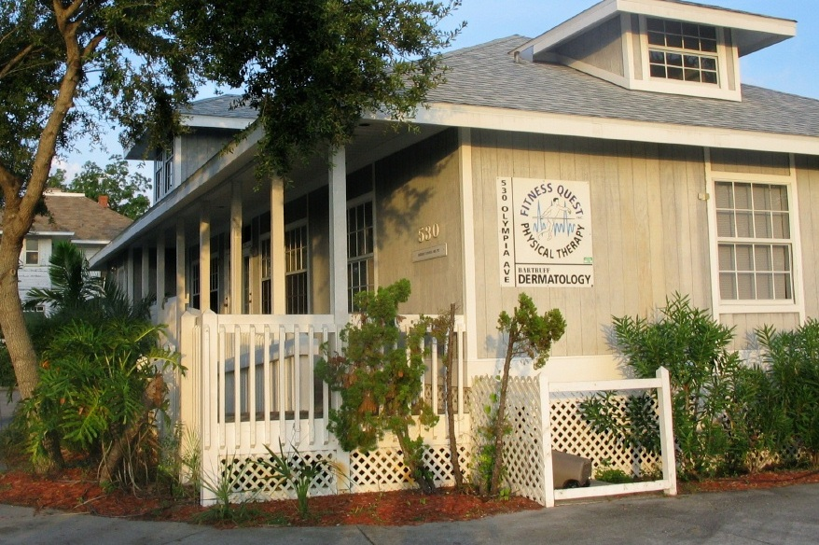
Phone Number: (941) 575-7300
Fax Number: (941) 505-7301
Staff Members: Rob Lovell
Description:
Hours 7-7
Location: Sarasota
Address:
1705 S. Osprey Ave.
Sarasota, FL 34239
Photo:
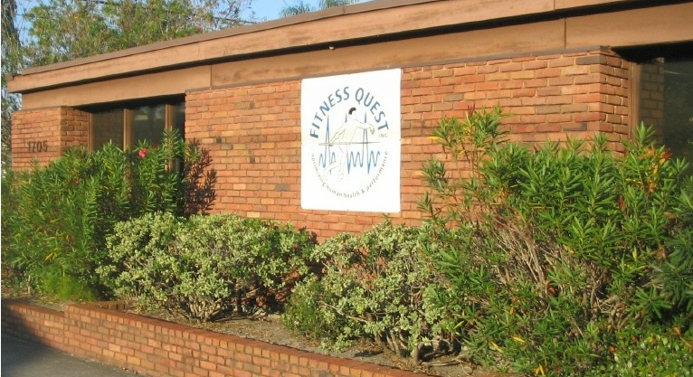
Phone Number: (941) 957-3279
Fax Number: (941) 957-0243
Staff Members: Michael Morrison
Description:
8-5
Location: Sarasota (d/tn)
Address: 1501 laurel street.
Sarasota, FL 34236
Photo:
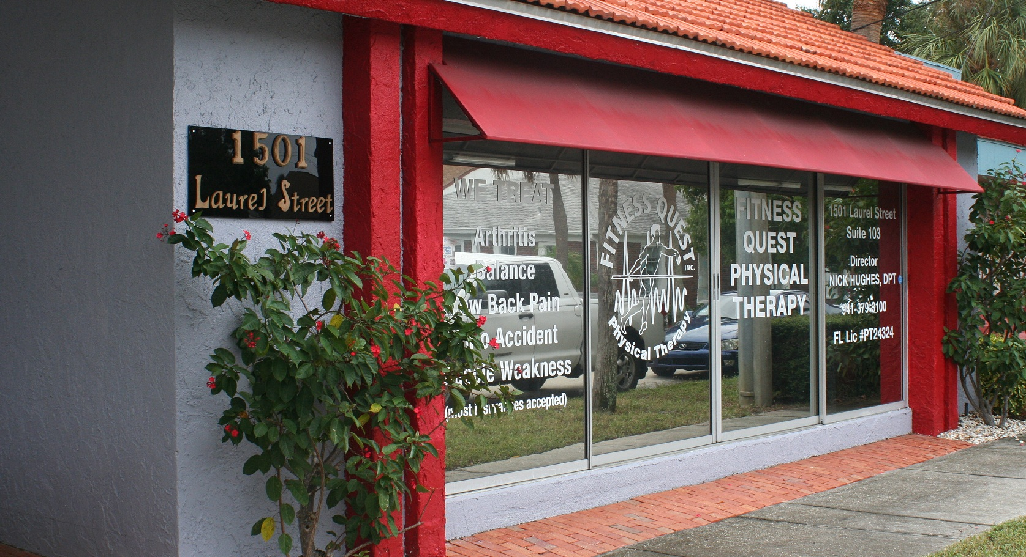
Phone Number: (941) 379-3100
Fax Number: (941) 379-3107
Staff Members: Nick Hughes
Description:
8-5
Location: Venice Island
Address:
400 S. Tamiami Trail #210
Venice, FL 34285
Photo:
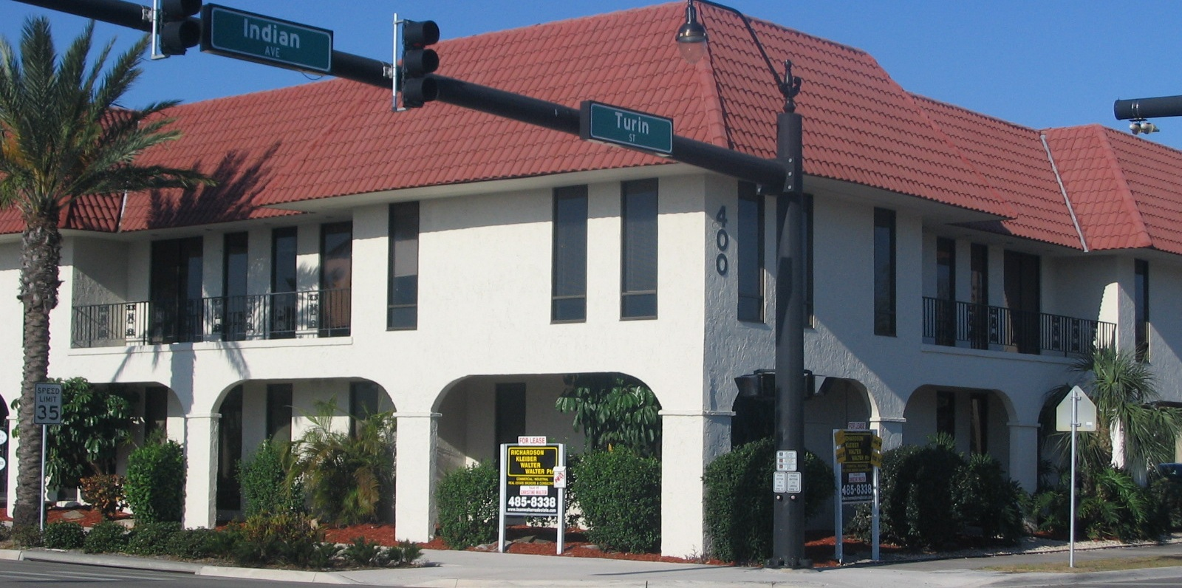
Phone Number: (941) 483-3400 / Pediatric
Fax Number: (941) 483-3422
Staff Members: Nicole Urbanowski, Michelle Harmon
Description:
Staff Biography Layout
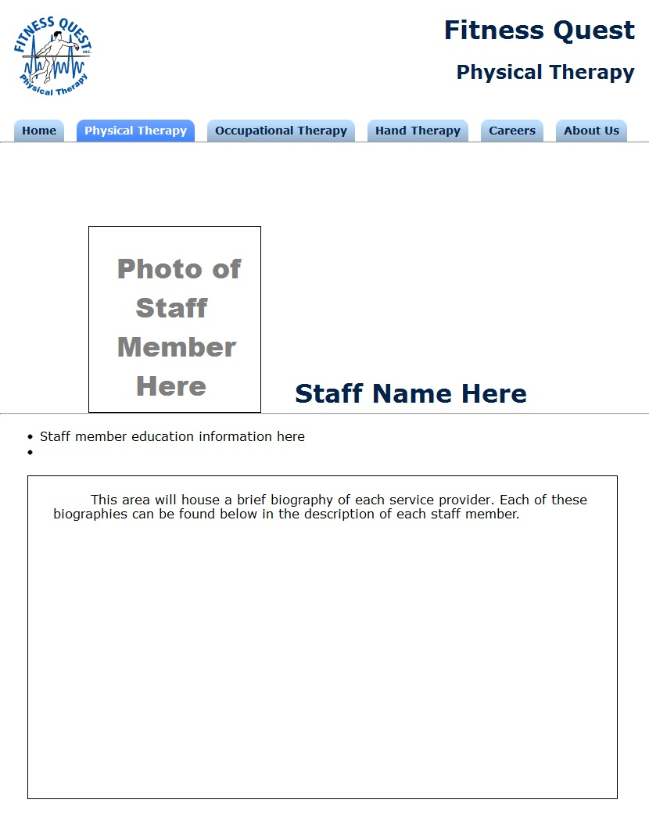
Name: Francisco Ramirez
Location: North Port
Education:
- Florida A&M University
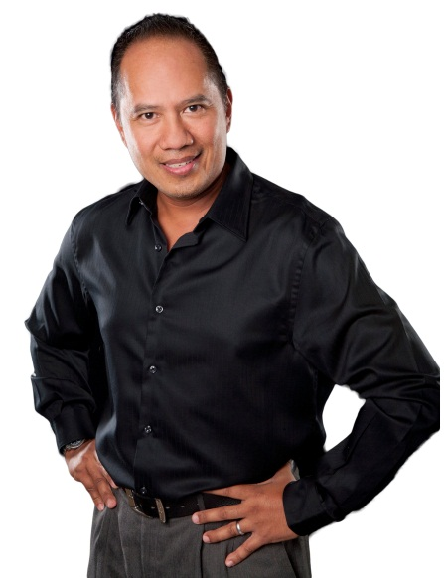

Photo:

Biography:
Our physical therapist and Director of Operations Francisco Ramirez grew up in Charlotte County. After graduating from Charlotte High School in 1981 he started a career with The Brown Derby restaurant in Fort Myers, Florida where he learned his customer service skills. Realizing his love for the medical field cultured by his parents who are physicians in Charlotte and Lee counties, he finished the physical therapy program at Florida A&M University located in Tallahassee, Florida. After eleven years of practice in a myriad of settings (acute, long term care, rehabilitation, sports clinic, spine clinic and outpatient) he brings vast knowledge of therapy catered to individual needs. He continues to expand his knowledge to stay updated with the latest research through continuing education and assisting in the establishment of post rehab protocols for Articular Joint Program for The Knee and the MedX protocol and he is also in the process of getting his certification for Hand Therapy. When not helping patients address their functional limitations, he loves to spend his free time with his family, enjoying fine North Port life among its great people. On any given weekend morning, you may spot him either riding his bicycle at break-neck speed or enjoying a run through the trails of North Port. Francisco Ramirez, PT- the therapist for the community.

Name: Karim Wassef
Location: Port Charolette
Education:
- Doctorate of Physical Therapy (DPT), Marymount University
- Certified Integrated Manual Therapist (CIMT), Great Lakes Institute of Manual Therapy
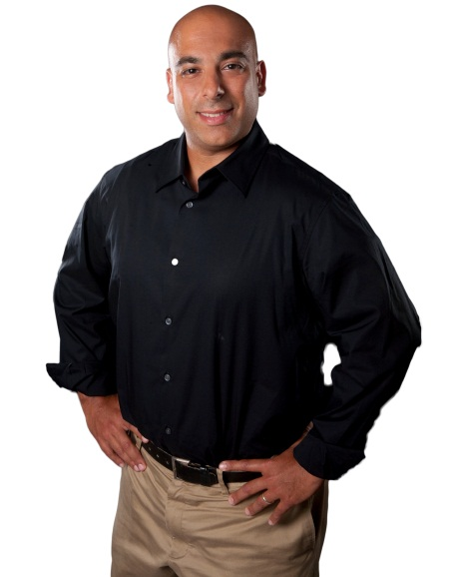

Photo:

Biography:
Each patient receives an individualized treatment plan to best reach their functional & personal goals. Treatments include manual techniques for bio-mechanical, neurological and soft tissue dysfunctions. Also, therapeutic exercise / activities & neurological reeducation to reinforce proper movement patterns, mechanics, as well as, strengthen and increase range of motion as needed. In addition, modalities are utilized for pain & swelling control. I am a first generation American-Egyptian born in Lexington, KY. I was raised as a Christian in the Washington D.C. metropolitan area, attended Eckerd College for my undergraduate education and grew to love the west coast of Florida. I became a physical therapist after experiencing the benefits of treatment following a motor vehicle accident, while in college. In my spare time I enjoy cycling both on & off road, building & riding motorcycles, snowboarding, playing music, & boating. When the opportunity came to relocate my family, my wife Courtney and son Kasen, I could not resist. I look forward to helping my patients to the best of my ability, being an active part of the community & enjoying the Florida lifestyle.

Name: Nicole Urbanowski
Location: Venice Island
Education:
- Masters of Science in Occupational Therapy, Boston University

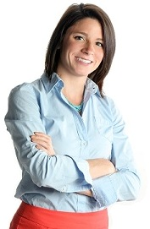

Photo:

Biography:
Nicole Urbanowski graduated from Boston University with a BS in Therapeutic Sciences and minor in Dance; and a Masters of Science in Occupational Therapy with a focus in Pediatrics. Nicole has recently relocated from the northeast where she fostered a passion for working with children in the school systems as well as afterschool and summer camp programs. Nicole believes that her excitement for pediatrics comes from the philosophy that children learn best while playing. Most recently, Nicole worked as the Program Director for YMCA Camp Lincoln in Kingston NH. Nicole’s experience includes pediatric outpatient service, school district caseload management including development and leadership of therapeutic groups for identified at-risk students within the school system.
Nicole is also a passionate dancer from a young age, competing and performing nationally and while in Boston, performing with local contemporary and ballet companies. Nicole is excited to be in Florida and join the Fitness Quest team.
Name: Nick Hughes
Location: Sarasota (dt)
Education:
- Doctorate with a specialty in sports medicine and outpatient orthopedics, University of Buffalo
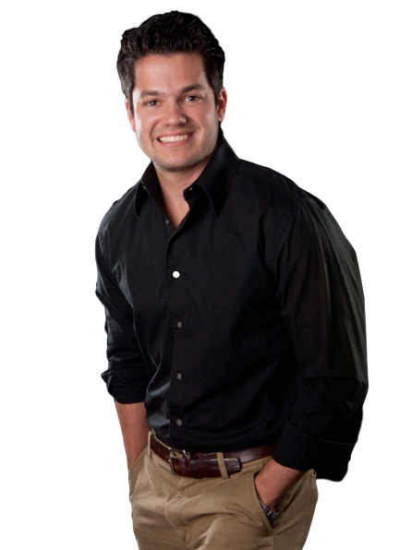

Photo:

Biography:
Nick is from Buffalo, NY and attended Fordham University. After an injury during a lacrosse game, he became involved in physical therapy. Nick graduated with a Doctorate from the University of Buffalo in 2008 with a specialty in sports medicine and outpatient orthopedics. With a strong manual therapy background, patients receive a combination of soft tissue mobilization, massage and exercise to relieve pain and increase daily function. Nick works closely with a pain management doctor to get you quickly back to a pain-free lifestyle.
Staff Biography: Mandy McHargue
Location: Sarasota
Education:
- Bachelor of Science degree with a focus in Exercise Science, University of Tampa
- Doctorate of Physical Therapy (DPT), University of St. Augustine
- Manual Therapy Certification (MTC)
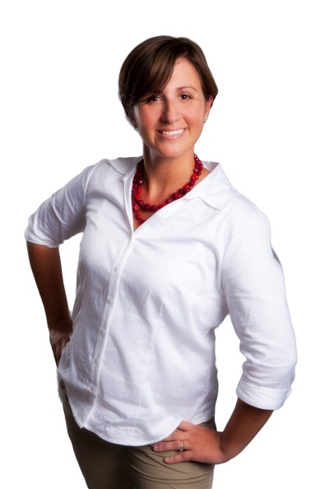

Photo:

Biography:
Clinical Director, Mandy McHargue, has been working for Fitness Quest in Sarasota since 2007. She is originally from Atlanta, GA. She graduated from the University of Tampa with a Bachelor of Science degree with a focus in Exercise Science. She then achieved a Doctorate in Physical Therapy from the University of St. Augustine (DPT). Mandy entered into Physical Therapy in order to help return people to a healthy and functional lifestyle. She enjoys being able to spend the one-on-one time with a patient to be able to create a patient specific program that better suits his/her needs. Mandy has a Manual Therapy Certification (MTC) and uses a hands-on approach in combination with therapeutic exercise to optimize results. Mandy was a competitive swimmer through college and continues to enjoy swimming more at a fitness level. She enjoys cooking and wine tasting in her spare time.
Name: Mary Beth
Location: Boca Grande
Education:
- Doctor of Physical Therapy (DPT), Marquette University
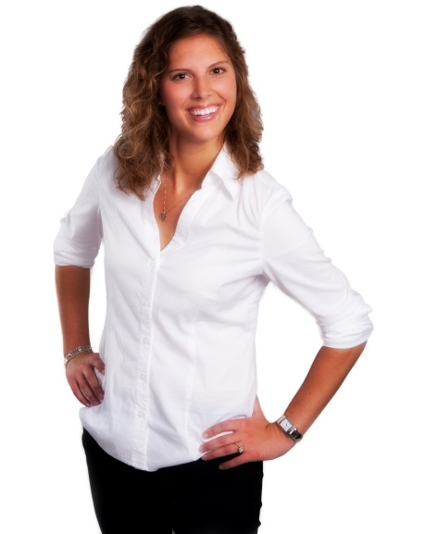

Photo:

Biography:
Mary is from Manitowoc, WI. She moved to Punta Gorda in May, 2011. I Graduated Magna Cum Laude from Marquette University's Doctor of Physical Therapy program in Milwaukee, WI in 2009. Continuing education in orthopedics, joint replacements, stroke recovery, and special interests in pilates and yoga inspired exercise. I entered the field of Physical Therapy because I am passionate about helping others to live and maintain an active lifestyle. I value the importance of taking the time to educate my patients on ways to prevent injury, restore functional mobility, and promote optimal health and wellness. My hobbies include running, cycling, volleyball, and, since moving to Florida, a beginning tennis player! Myself and the entire staff at Fitness Quest thoroughly understand the intricate system of how the human body moves and are professionally trained to create individual treatment plans to assist you in getting back on track.
Name: Michael Morrison
Location: Sarasota
Education:
- Bachelor of Science in Kinesiology, The College of William and Mary
- Doctor of Physical Therapy (DPT), University of Colorado

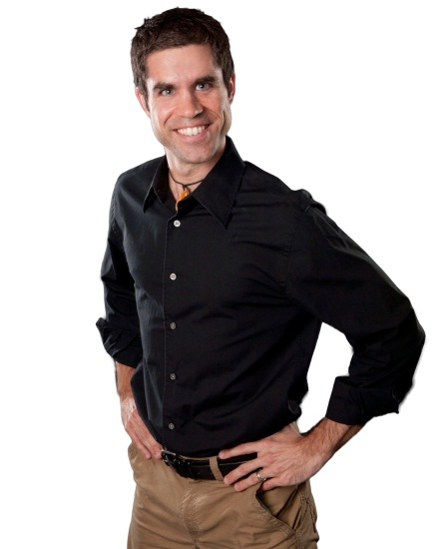

Photo:

Biography:
Michael Morrison DPT has been part of the Fitness Quest team since 2008. He received his Bachelor of Science in Kinesiology from The College of William and Mary in 2001, and earned his Doctor of Physical Therapy degree from the University of Colorado, where he was the president of his class, in 2008. While in grad school Michael had the opportunity to study in Australia where he refined his manual intervention skills which he uses in conjunction with individualized exercises to improve overall function and quality of life for his patients. Michael also has training in running analysis and injury prevention/treatment for runners.
Michael became interested in physical therapy because he is a self-described “people person” who loves to encourage others to perform at their best and enjoy healthy living. You will see from your first visit that he cares about giving you the individual attention and treatment that is appropriate for your situation and will get you back to the things that are important in your life.
Michael is an avid distance runner who enjoys ½ marathons, triathlons, and just about any sport, specifically, soccer. He also enjoys camping and hiking and has recently begun section hiking the Appalachian Trail with his brother. He also loves hanging out with his beautiful wife, who is an amazing cook, musician, and photographer.
Name: Michelle Harmon
Location: Venice Island
Education:
- Bachelor’s degree in Exercise and Sports Science, Texas State University
- Doctorate in Physical Therapy (DPT), University of South Florida
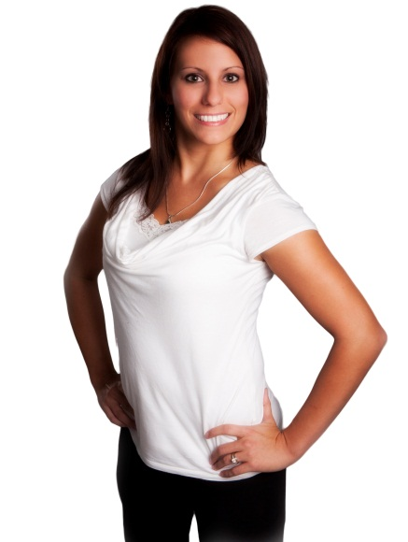

Photo:

Biography:
Michelle Harmon, DPT is the Clinical Director for Fitness Quest Physical Therapy in Venice, Florida. Michelle was born and raised in Houston, Texas. She attended Texas State University and received her bachelor’s degree in Exercise and Sports Science in 2006. From there she moved to Florida and began training for her Doctoral degree in Physical Therapy at the University of South Florida. In 2009 she earned her Doctorate in Physical Therapy and moved to Sarasota to begin her career. Michelle specializes in orthopedic, sports and spine physical therapy, as well as vestibular rehabilitation. Her treatments emphasize the integration of manual techniques and therapeutic exercise in orthopedic rehabilitation.
Michelle is a member of the American Physical Therapy Association (APTA) and CPR certified. Michelle is committed to enhancing her skills as a physical therapist by continuing her education with courses in manual therapy, spinal disorders, vestibular rehabilitation, and foot and ankle disorders. Michelle has developed an environment where patients can receive one on one care, regain functional mobility, and return to a healthier lifestyle. In her spare time she enjoys spending time with family and friends, participating in exercise and recreational activities, and traveling.
Name: Rob Lovell
Location: Punto Gorda
Education:
- Bachelor of Science & Chemistry minor, University of North Carolina at Chapel Hill
- Master of Science in Physical Therapy, University Of Miami School Of Medicine
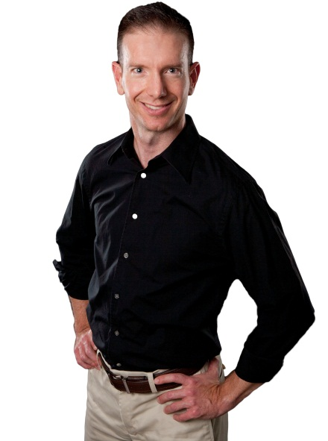

Photo:

Biography:
Rob graduated on the Dean’s List from the University of North Carolina at Chapel Hill with a Bachelor of Science degree and Chemistry minor. He completed his graduate studies with honors at the University Of Miami School Of Medicine with a Master of Science degree in Physical Therapy. He graduated with a 3.9 GPA on a 4.0 scale. Rob has practiced physical therapy for over twelve years. He has worked exclusively in private practice and with adults with orthopedic and neurological conditions. Rob and his partners opened up Fitness Quest Punta Gorda in May 2004 to provide the highest quality physical therapy services for the residents of Charlotte County.
He has extensive experience in the physical therapy evaluation and treatment of patients with Spine, Shoulder, Elbow, Wrist/Hand, Balance/Vestibular, Neurological, Hip, Knee, and Foot/Ankle impairments. Rob has contributed to the professional physical therapy literature. He has published research on muscle fatigue and range of motion measurement and was awarded the designation of Certified Clinical Instructor by the Florida Consortium of Clinical Educators in June of 2006. A strong believer in clinical education, Rob has attended multiple continuing education courses on the spine, shoulder, knee, geriatric orthopedics, ergonomics, and balance/fall prevention.
Name: Shelia Flaherty
Location: Port Charlotte
Education:
- Bachelor of Science degree in Occupational Therapy, University of Florida
- Certification in Hand Therapy (CHT)
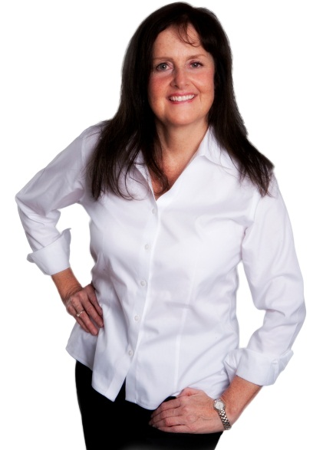

Photo:

Biography:
I was born in Ontario, Canada. After relocating to Florida, I eventually attended the University of Florida and graduated with honors with a Bachelor of Science degree in Occupational Therapy. During my early years of practice in Occupational Therapy, I developed a special interest in Hand Rehabilitation. With a strong desire for advanced competency and a personal dedication to the profession of Hand Therapy, I ultimately obtained my certification in Hand Therapy in 1991, becoming the first Certified Hand Therapist in Charlotte County. Certification involves meeting rigorous standards and acquiring advanced training and study in order to pass the certification examination. The CHT credential provides assurance that the therapist has attained the highest level of competency in the profession and remains current with practice within the field. Since obtaining my certification and successfully recertifying every 5 years, I continue to derive great personal satisfaction from helping people achieve the maximum restoration of their hand function following injury. I am a member of the American Society of Hand Therapists, American Occupational Therapy Association, Florida Hand Society and the Florida Occupational Therapy Association. Outside of work, I enjoy spending time with my family, art, traveling, swimming, biking, hiking, yoga and giving back to the community.

